Eg: Array_Eg15
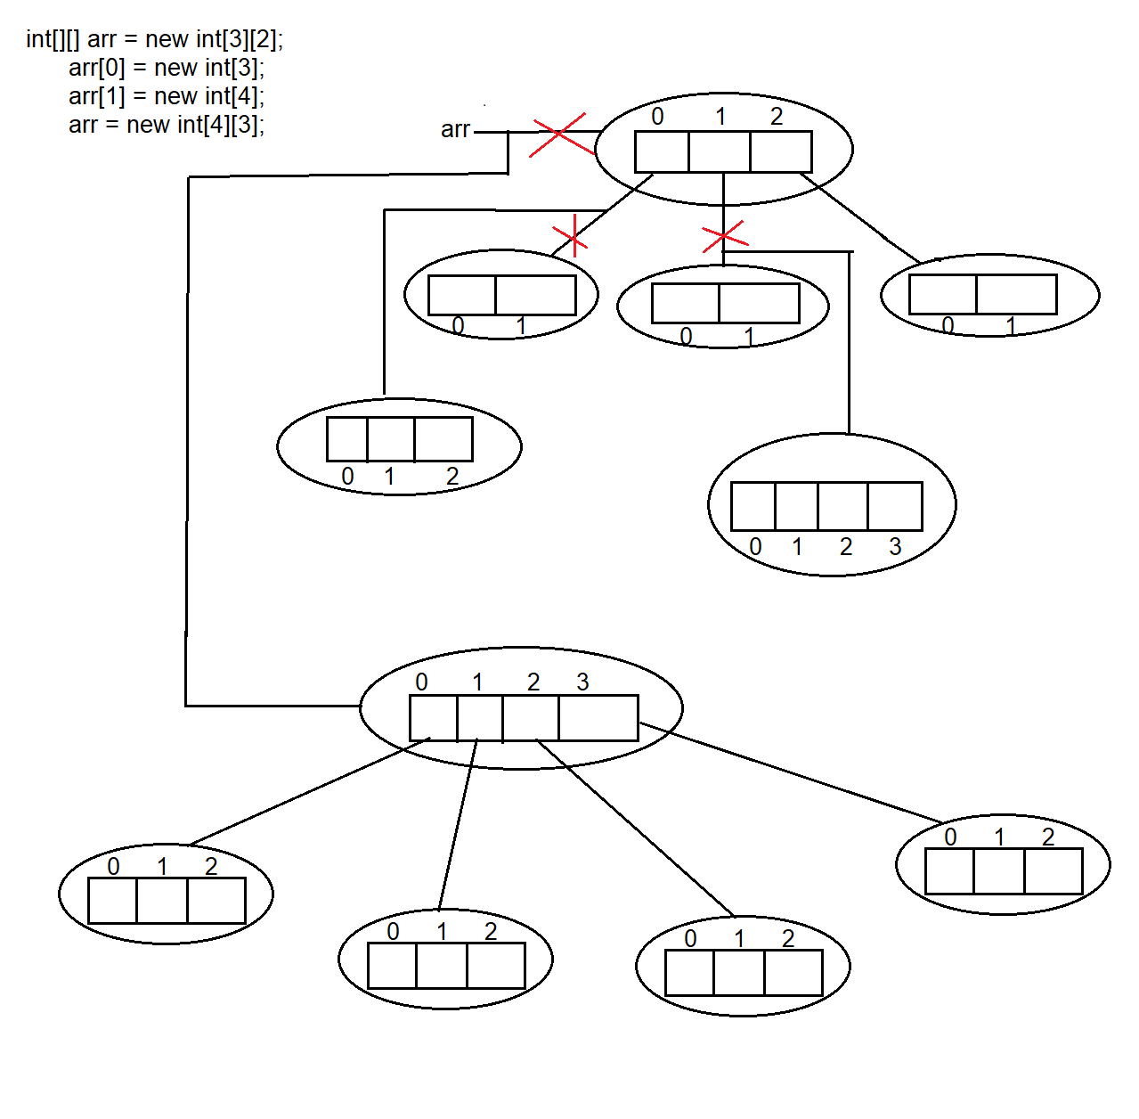
Total objects created = 11
Objects eligible for garbage collection = 6
Red coloured cross marks indicate that references were reassigned or lost.
Since no reference variable points to these objects anymore, they become eligible for garbage collection.
Actual memory cleanup is performed later by the Garbage Collector, not immediately.

Eg: Array_Eg16
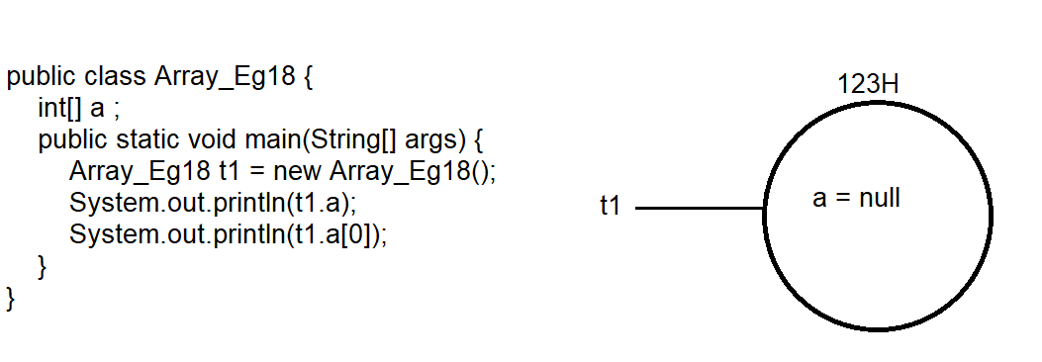
First, the main method is executed and an object t1 is created.
Inside this object, an int array reference variable a is created.
The array object is created only when the new keyword is used.
Here, no new keyword is used for a, so no array object is created.
The JVM identifies a as a reference variable and assigns it the default value null.
Note: For all instance reference variables, the default value is null when the object is created using the new keyword.
When t1.a is printed, null is printed.
When t1.a[0] is executed, we are trying to access an element on a null reference, which leads to a NullPointerException.

Eg: Array_Eg17
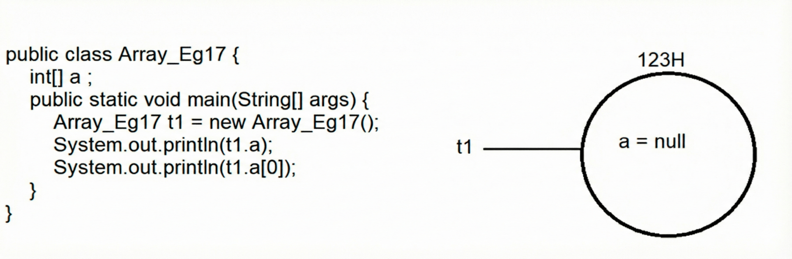

Eg: Array_Eg18
// go through the code

Eg: Array_Eg19
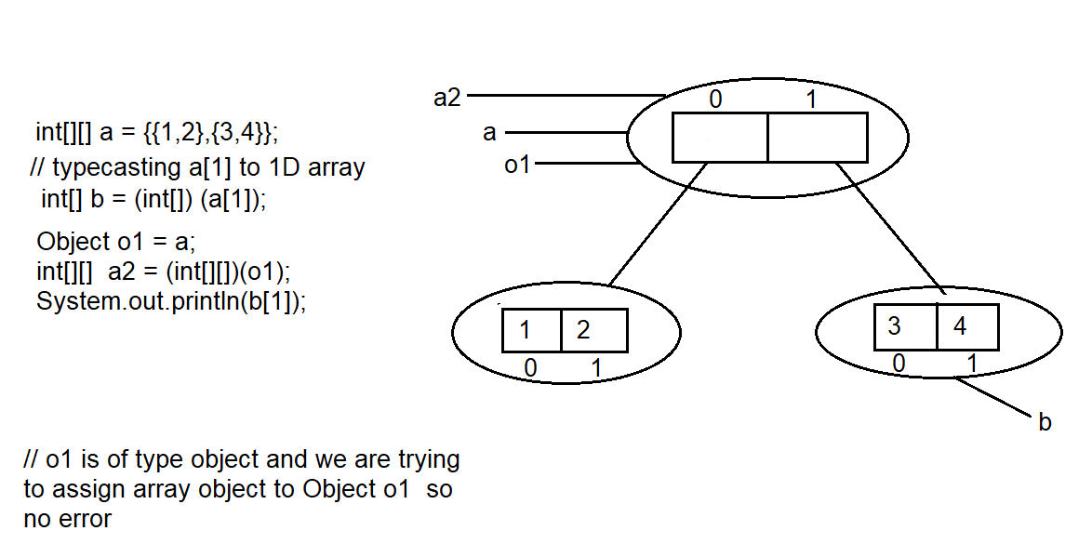

Eg: Array_Eg20
// go through the program.

Eg: Array_Eg21
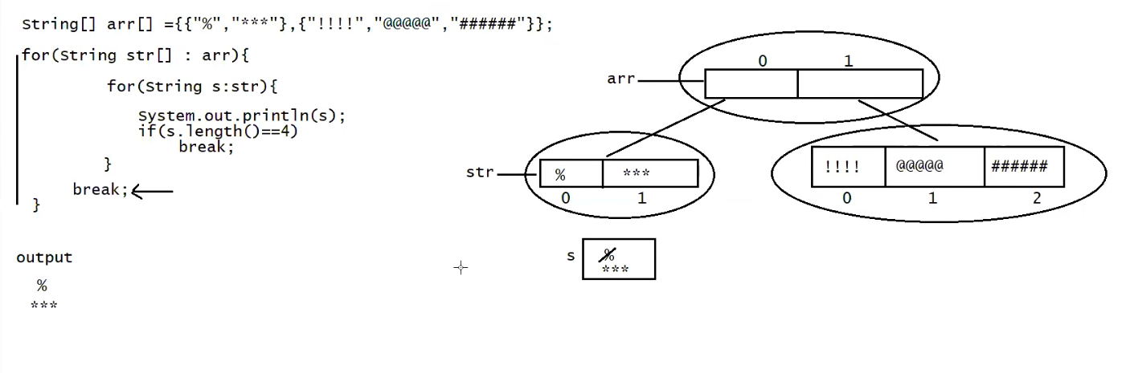

🧠 DRY RUN (STEP BY STEP)

🔹 Initial State
- arr has 2 rows
  - Row 0 → {"%", "***"}
  - Row 1 → {"!!!!", "@@@@@", "######"}

▶ OUTER LOOP – 1st iteration
for (String[] str : arr)
- str now points to first row
- str = {"%", "***"}

▶ INNER LOOP – 1st iteration
for (String s : str)
- s = "%"
- s.length() → 1

Execution:
System.out.println(s);
Output:
%
if (s.length() == 4) // 1 == 4 → false
- Condition is false
- break NOT executed
- Move to next inner iteration

▶ INNER LOOP – 2nd iteration
- s = "***"
- s.length() → 3

Execution:
System.out.println(s);
Output:
***
if (s.length() == 4) // 3 == 4 → false
- Condition is false
- break NOT executed
- Inner loop ends (no more elements)

▶ INNER LOOP ENDS
- Control comes outside inner loop
- Now execution reaches:
break;

❌ OUTER LOOP BREAK EXECUTES
- This break belongs to outer loop
- Outer loop stops immediately
- Second row is never processed

❌ SECOND ROW (NEVER EXECUTED)
{"!!!!", "@@@@@", "######"}
- Code never reaches here
- "!!!!" is never checked
- Inner break (length == 4) is never triggered

🖨 FINAL OUTPUT
%
***

🧩 KEY UNDERSTANDING (VERY IMPORTANT)

🔸 Why inner break did NOT run?
Because:
- "%" → length 1
- "***" → length 3
- No string of length 4 in first row

🔸 Why outer loop stopped?
Because of this line:
break;
outside the inner loop

🧠 ONE-LINE SUMMARY
Program prints only first row elements and stops completely.

Eg: Array_Eg22

🔁 Code under dry run
String[][] arr = {
{"%", "***"},
{"!!!!", "@@@@@", "######"}
};

for (String[] str : arr) {
for (String s : str) {
System.out.println(s);
if (s.length() == 4)
break;
}
}

🧠 INITIAL STATE
- arr has 2 rows
  - Row 0 → {"%", "***"}
  - Row 1 → {"!!!!", "@@@@@", "######"}

▶ OUTER LOOP – 1st iteration
str = {"%", "***"}

▶ INNER LOOP (Row 0)

🔹 Inner – 1st iteration
- s = "%"
- s.length() → 1
Execution:
print "%"
1 == 4 → false → no break

🔹 Inner – 2nd iteration
- s = "***"
- s.length() → 3
Execution:
print "***"
3 == 4 → false → no break

🔹 Inner loop ends (no more elements)
Control goes back to outer loop.

▶ OUTER LOOP – 2nd iteration
str = {"!!!!", "@@@@@", "######"}

▶ INNER LOOP (Row 1)

🔹 Inner – 1st iteration
- s = "!!!!"
- s.length() → 4
Execution:
print "!!!!"
4 == 4 → true → break
- break executes
- Inner loop stops immediately
- "@@@@@" and "######" are NOT executed

▶ INNER LOOP STOPS
Control goes back to outer loop.
- No more rows in arr
- Outer loop ends

🖨 FINAL OUTPUT
%
***
!!!!

Eg: Array_With_Variable_Arguments
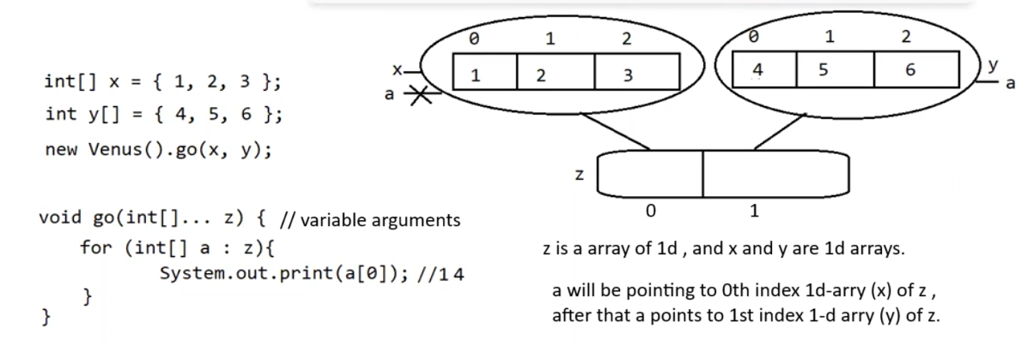

🧠 WHAT int[]... z REALLY MEANS

🔹 VERY IMPORTANT RULE
int[]... z ≡ int[][] z
📌 Var-args is just syntax sugar
At compile time, Java converts it into:
void go(int[][] z)
👉 JVM does NOT know about var-args
👉 JVM sees only 2D array

▶ DRY RUN – STEP BY STEP

🔹 STEP 1: Object Creation
Array_With_Variable_Arguments obj = new Array_With_Variable_Arguments();

Memory:
- obj created in heap
- Instance variables initialized:
  - x → {1,2,3}
  - y → {4,5,6}

🔹 STEP 2: Method Call
obj.go(obj.x, obj.y);

What compiler does internally:
obj.go(new int[][] { obj.x, obj.y });
So now:
z → int[][] {
{1,2,3},
{4,5,6}
}

🔹 STEP 3: Method Entry
void go(int[]... z)
📌 Inside method:
- z is a 2D array
- z.length == 2

🔹 STEP 4: for-each loop starts
for (int[] a : z)

❓ What is a?
- a is ONE int[] at a time
- NOT a single int
- NOT a copy
- It is a reference to existing array

▶ for-each — 1st iteration
a → z[0] → {1,2,3}
Execution:
System.out.println(a[0]); // 1
System.out.println(a[1]); // 2
System.out.println(a[2]); // 3
Output:
1
2
3

▶ for-each — 2nd iteration
a → z[1] → {4,5,6}
Execution:
System.out.println(a[0]); // 4
System.out.println(a[1]); // 5
System.out.println(a[2]); // 6
Output:
4
5
6

🔹 STEP 5: Method Ends
- go() finishes
- Control returns to main()

🔹 STEP 6: Last Loop in main
for (int x : obj.y)
Iteration:
- Prints: 456 (no space or newline)

🖨 FINAL OUTPUT
1
2
3
4
5
6
456

🔑 PROBABLE NOTES (VERY IMPORTANT)

⭐ 1. Var-args is always an ARRAY
int... a → int[]
int[]... z → int[][]

⭐ 2. Var-args must be LAST parameter
void m(int x, int... y) ✅
void m(int... y, int x) ❌

⭐ 3. for-each over var-args
for (int[] a : z)
- a is not copied
- a points to original arrays (x and y)

⭐ 4. Modifying a modifies original array
a[0] = 99; // will change obj.x or obj.y

⭐ 5. This will throw exception
obj.go(); // z.length = 0
a[0] → ArrayIndexOutOfBoundsException

🧠 ONE-LINE SUMMARY
Var-args of arrays is nothing but a 2D array, and for-each iterates row by row.

✅ Your statement — VERIFIED

1️⃣ void method(int... a)
✔ This is variable arguments of int
✔ You can pass any number of integers
Examples:
method(); // zero ints
method(1); // one int
method(1, 2, 3, 4); // many ints
👉 Internally becomes:
int[] a

✅ Your understanding — CONFIRMED

1️⃣ void method(int[]... a)
✔ Variable arguments of 1-D arrays
✔ You can pass multiple int[] arrays
Internal form:
int[][] a
Example:
method(arr1, arr2, arr3);

2️⃣ void method(int[][]... a)
✔ Variable arguments of 2-D arrays
✔ You can pass multiple int[][] arrays
Internal form:
int[][][] a
Example:
method(matrix1, matrix2);

3️⃣ void method(int[][][]... a)
✔ Variable arguments of 3-D arrays
✔ You can pass multiple int[][][] arrays
Internal form:
int[][][][] a
Example:
method(cube1, cube2, cube3);

🧠 GOLDEN RULE (CORE CONCEPT)
Var-args adds ONE extra dimension on top of the declared array type.
So:
Base type dimension + 1 = internal dimension

Eg: Static_Array
// go through the code

Eg: Array_Eg23

Eg: Array_Eg24

▶ OUTER LOOP — Iteration by Iteration

🔹 OUTER LOOP — 1st iteration
x = 1

INNER LOOP STARTS

j = 0
- Check: x > 4 && x < 8 → 1 > 4 ❌
- Print: 1
- j == 1 → ❌
- continue → next j

j = 1
- Check: 1 > 4 && 1 < 8 ❌
- Print: 1
- j == 1 → ✅
- break → inner loop stops

🔹 OUTER LOOP — 2nd iteration
x = 3

INNER LOOP STARTS

j = 0
- Condition false
- Print: 3
- continue

j = 1
- Condition false
- Print: 3
- j == 1 → break inner loop

🔹 OUTER LOOP — 3rd iteration
x = 5

INNER LOOP STARTS

j = 0
- Check: 5 > 4 && 5 < 8 → TRUE
- continue → skip print

j = 1
- Same condition TRUE
- continue

j = 2
- Same condition TRUE
- continue
➡ Inner loop ends naturally
➡ Nothing printed for x = 5

🔹 OUTER LOOP — 4th iteration
x = 7

INNER LOOP STARTS

j = 0
- 7 > 4 && 7 < 8 → TRUE
- continue

j = 1
- continue

j = 2
- continue
➡ Inner loop ends
➡ Nothing printed for x = 7

🔹 OUTER LOOP — 5th iteration
x = 9

INNER LOOP STARTS

j = 0
- 9 > 4 && 9 < 8 → FALSE
- Print: 9
- continue

j = 1
- Condition FALSE
- Print: 9
- j == 1 → break inner loop

🖨 FINAL OUTPUT
1 1 3 3 9 9

🔑 KEY TAKEAWAYS (VERY IMPORTANT)
- continue skips remaining statements in the current loop
- break stops only the nearest loop
- Values 5 and 7 never print due to continue
- Inner loop prints max 2 times per valid element

🧠 ONE-LINE SUMMARY
The program prints each number twice, except 5 and 7, which are skipped completely

